**Java - Introduction to Programming**

**Lecture 5**

**Patterns - Part 1**



import java.util.*;

public class Patterns {

public static void main(String args[]) {

int n = 5;

int m = 4;

for(int i=0; i<n; i++) {

for(int j=0; j<m; j++) {

System.out.print("*");

}

System.out.println();

}

}

}

1. 

import java.util.*;

public class Patterns {

public static void main(String args[]) {

int n = 5;

int m = 4;

for(int i=0; i<n; i++) {

for(int j=0; j<m; j++) {

if(i == 0 || i == n-1 || j == 0 || j == m-1) {

System.out.print("*");

} else {

System.out.print(" ");

}

}

System.out.println();

}

}

}

1. 

import java.util.*;

public class Patterns {

public static void main(String args[]) {

int n = 4;

for(int i=1; i<=n; i++) {

for(int j=1; j<=i; j++) {

System.out.print("*");

}

System.out.println();

}

}

}

1. 

import java.util.*;

public class Patterns {

public static void main(String args[]) {

int n = 4;

for(int i=n; i>=1; i--) {

for(int j=1; j<=i; j++) {

System.out.print("*");

}

System.out.println();

}

}

}



import java.util.*;

public class Patterns {

public static void main(String args[]) {

int n = 4;

for(int i=n; i>=1; i--) {

for(int j=1; j<i; j++) {

System.out.print(" ");

}

for(int j=0; j<=n-i; j++) {

System.out.print("*");

}

System.out.println();

}

}

}

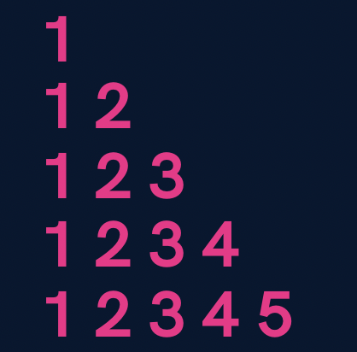

**import java.util.*;**

**public class Patterns {**

**public static void main(String args[]) {**

**int n = 5;**

**for(int i=1; i<=n; i++) {**

**for(int j=1; j<=i; j++) {**

**System.out.print(j);**

**}**

**System.out.println();**

**}**

**}**

**}**

1. 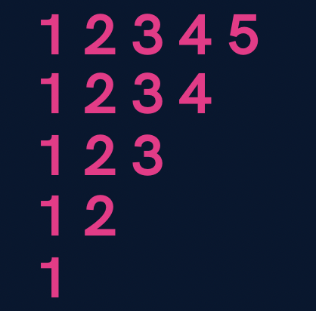

**import java.util.*;**

**public class Patterns {**

**public static void main(String args[]) {**

**int n = 5;**

**for(int i=n; i>=1; i--) {**

**for(int j=1; j<=i; j++) {**

**System.out.print(j);**

**}**

**System.out.println();**

**}**

**}**

**}**

1. 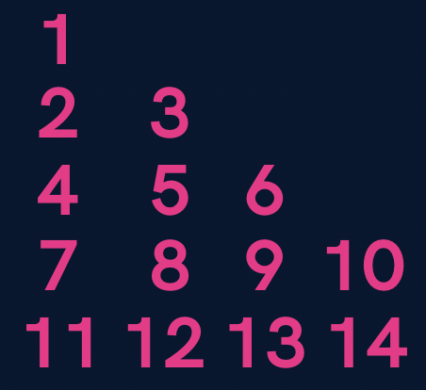

**import java.util.*;**

**public class Patterns {**

**public static void main(String args[]) {**

**int n = 5;**

**int number = 1;**

**for(int i=1; i<=n; i++) {**

**for(int j=1; j<=i; j++) {**

**System.out.print(number+" ");**

**number++;**

**}**

**System.out.println();**

**}**

**}**

**}**

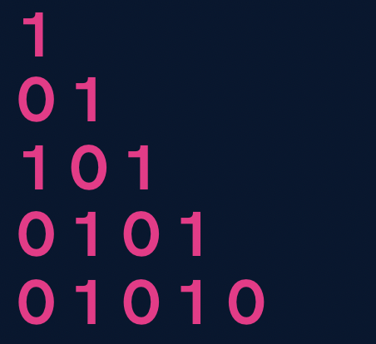

**import java.util.*;**

**public class Patterns {**

**public static void main(String args[]) {**

**int n = 5;**

**for(int i=1; i<=n; i++) {**

**for(int j=1; j<=i; j++) {**

**if((i+j) % 2 == 0) {**

**System.out.print(1+" ");**

**} else {**

**System.out.print(0+" ");**

**}**

**}**

**System.out.println();**

**}**

**}**

**}**

**Homework Problems (Solutions in next Lecture’s Video)**

1. Print a solid rhombus.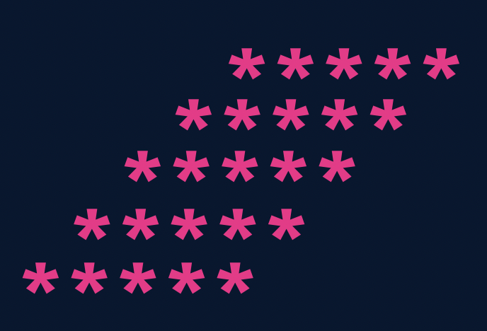
2. Print a number pyramid.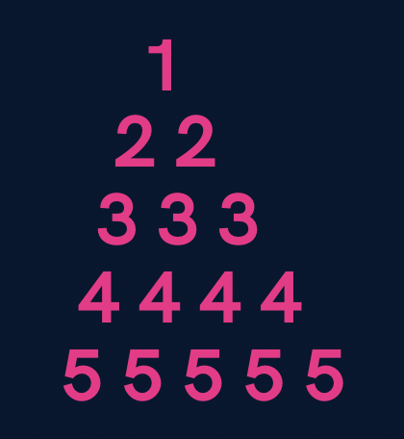
3. Print a palindromic number pyramid.

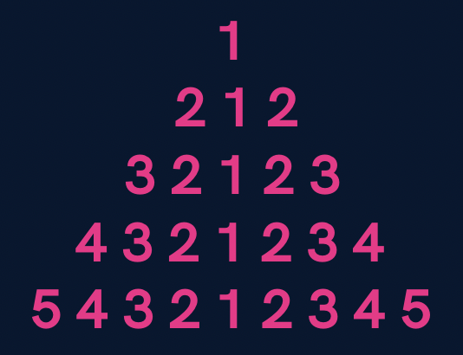

**Homework Solution (Lecture 4)**

1. Print all even numbers till n.
2. public class Solutions {
3. public static void main(String args[]) {
4. int n = 25;
5. for(int i=1; i<=n; i++) {
6. if(i % 2 == 0) {
7. System.out.println(i);
8. }
9. }
10. }
11. }

**3.**  Make a menu driven program. The user can enter 2 numbers, either 1 or 0.

If the user enters 1 then keep taking input from the user for a student’s marks(out of 100).

If they enter 0 then stop.

If he/ she scores :

**Marks >=90** -> print “This is Good”

**89 >= Marks >= 60** -> print “This is also Good”

**59 >= Marks >= 0** -> print “This is Good as well”

Because marks don’t matter but our effort does.

(Hint : use do-while loop but think & understand why)

**import java.util.*;**

**public class Solutions {**

**public static void main(String args[]) {**

**Scanner sc = new Scanner(System.in);**

**int input;**

**do {**

**int marks = sc.nextInt();**

**if(marks >= 90 && marks <= 100) {**

**System.out.println("This is Good");**

**} else if(marks >= 60 && marks <= 89) {**

**System.out.println("This is also Good");**

**} else if(marks >= 0 && marks <= 59) {**

**System.out.println("This is Good as well");**

**} else {**

**System.out.println("Invalid");**

**}**

**System.out.println("Want to continue ? (yes(1) or no(0))");**

**input = sc.nextInt();**

**} while(input == 1);**

**}**

**}**

Qs. Print if a number n is prime or not (Input n from the user).

[In this problem you will learn how to check if a number is prime or not]

**import java.util.*;**

**public class Solutions {**

**public static void main(String args[]) {**

**Scanner sc = new Scanner(System.in);**

**int n = sc.nextInt();**

**boolean isPrime = true;**

**for(int i=2; i<=n/2; i++) {**

**if(n % i == 0) {**

**isPrime = false;**

**break;**

**}**

**}**

**if(isPrime) {**

**if(n == 1) {**

**System.out.println("This is neither prime not composite");**

**} else {**

**System.out.println("This is a prime number");**

**}**

**} else {**

**System.out.println("This is not a prime number");**

**}**

**}**

**}**